CLOUD COMPUTING LAB


SUBMITTED TO
ENGR. SHOAIB & SIR WAQAS

SUBMITTED BY
HAMNA MAHMOOD
2023-BSE-025
BSE V-A

Lab 13
Terraform IAM Management with AWS
Task 0 Lab Setup (Codespace & GH CLI)
- task0_codespace_create_and_list.png
- task0_codespace_ssh_connected.png
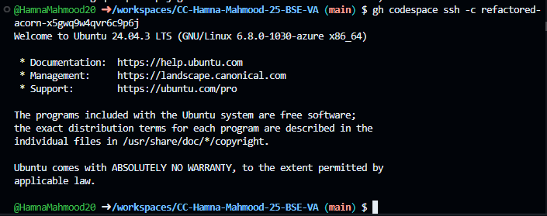
Task 1 Create IAM Group and Output Details
- task1_project_directory.png
- task1_file_created.png
- task1_main_tf.png
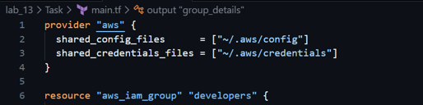
- task1_terraform_init.png
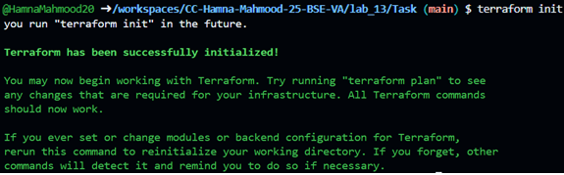
- task1_terraform_apply.png
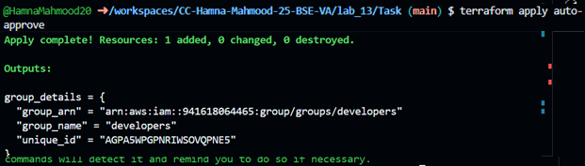
- task1_terraform_output.png
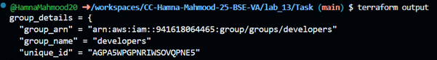
- task1_aws_console_group.png
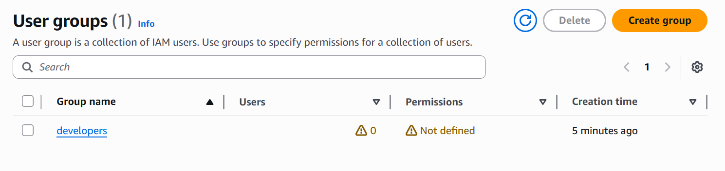
Task 2 – Create IAM User with Group Membership
- task2_main_tf_user.png
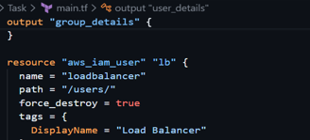
- task2_terraform_apply.png
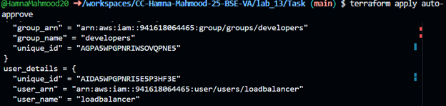
- task2_terraform_output.png
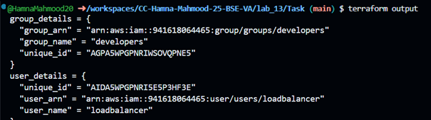
- task2_aws_console_user.png
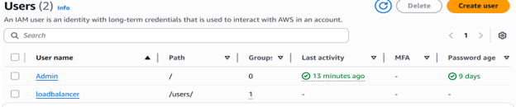

- task2_aws_console_user_groups.png
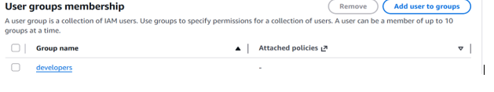
Task 3 – Attach Policies to IAM Group
- task3_main_tf_policies.png
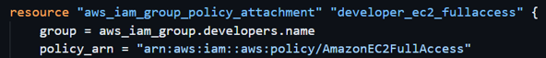
- task3_terraform_apply.png
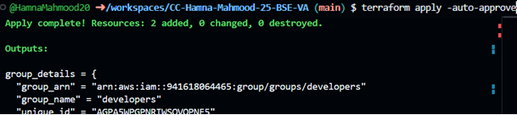
- task3_aws_console_policies.png
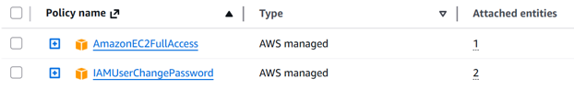
Task 4 – Create Login Profile for IAM User
- task4_variables_tf.png
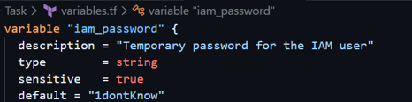
- task4_create_login_script.png
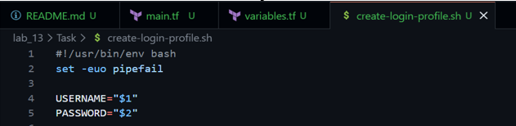
- task4_chmod_script.png
- task4_terraform_apply.png
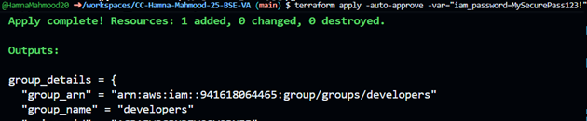
- task4_aws_cli_verify.png
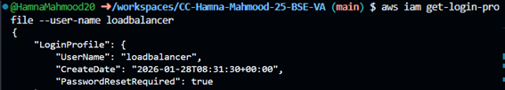
- task4_aws_console_login.png

- task4_aws_console_password_reset.png
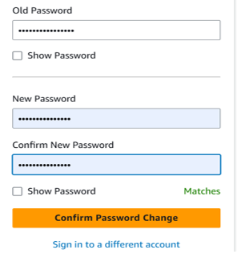
Task 5- Generate Access Keys for IAM Users
- task5_main_tf_access_keys.png
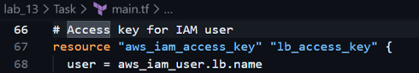
- task5_terraform_apply.png
- task5_tfstate_secret. Png
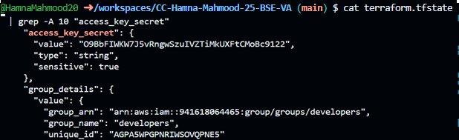
- task5_aws_console_access_keys. Png
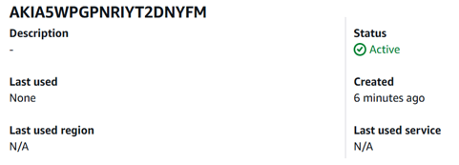
Task 6 – Implement Terraform State with S3
- task6_s3_bucket_create.png
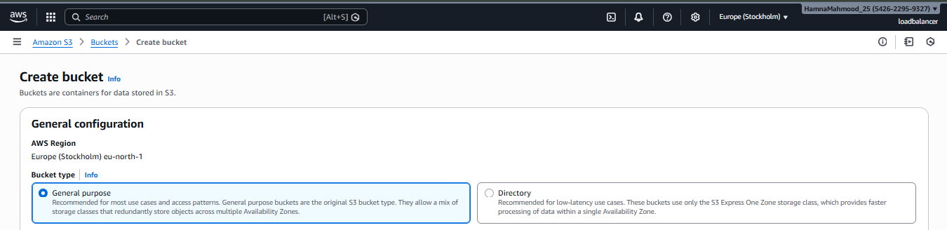
- task6_s3_bucket_versioning.png
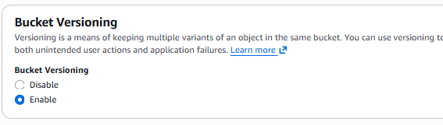
- task6_terraform_init_migrate.png
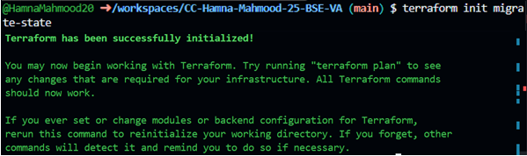
- task6_terraform_apply.png
- task6_s3_tfstate_file.png
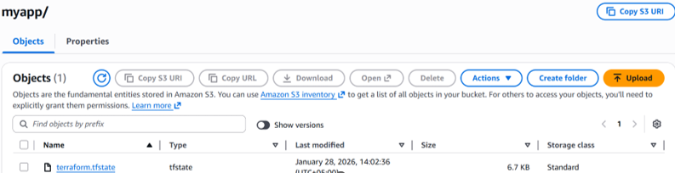
- task6_terraform_destroy.png
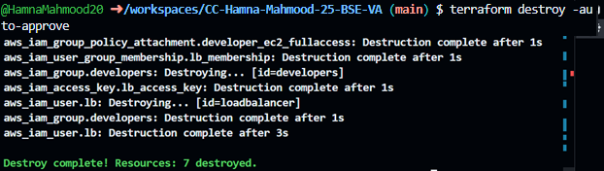
- task6_s3_tfstate_destroyed.png
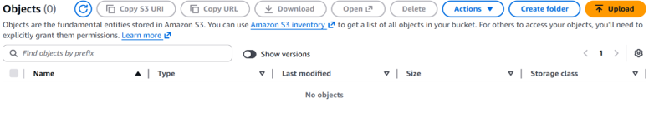
Task 7 – Create Multiple Users From CSV File
- task7_locals_tf.png
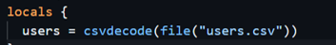
- task7_users_csv.png
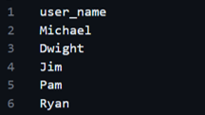
- task7_main_tf_multiple_users.png
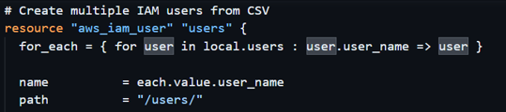
- task7_terraform_apply.png
- task7_terraform_output.png
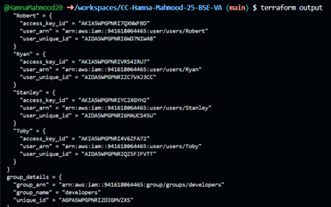
- task7_tfstate_secrets. Png

- task7_aws_console_all_users. Png
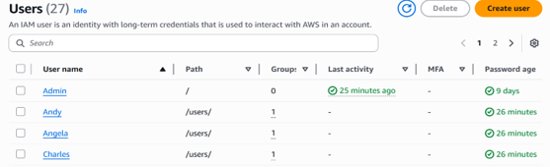
- task7_aws_console_group_members. Png
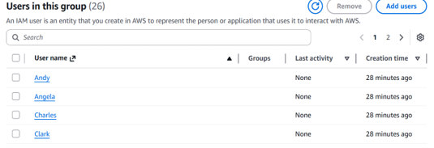
- task7_aws_console_user_access_key.png
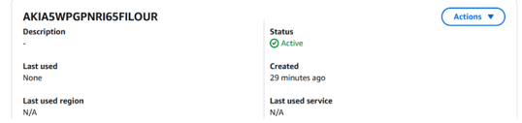
- task7_s3_tfstate_multiple_users.png
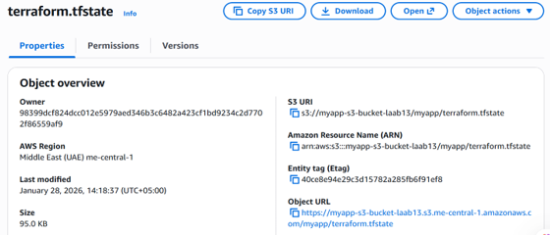
Cleanup
- cleanup_destroy_complete.png
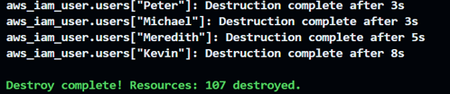
- cleanup_aws_console_users_deleted.png
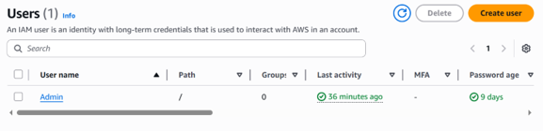
- cleanup_aws_console_group_deleted.png
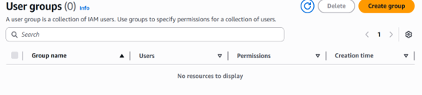
- cleanup_s3_empty_state.png
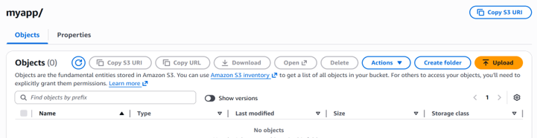
- cleanup_final_files.png
